Master Data Management via Registry Platform
Synced to the Master Data Service (MDS)
1. Document Information
Field | Details
Document Name | Master Data Management via Registry Platform — Synced to Master Data Service
Program / Project | OpenAgriNet (OAN) — Master Data Management
Prepared By | Faiz Mohammed
Date | September 2026
Version | 1.0 (Draft for review)
Scope | Design pattern for governing master data in a dedicated MDM Registry and syncing approved changes to the Master Data Service (MDS)
2. Revision History
Version | Date | Description of Change | Author
1.0 | September 2026 | Initial draft for review | Faiz Mohammed
3. Overview
Master data — Location, Crop, Seed, and similar reference/catalog domains — is authored and approved inside a dedicated Registry Platform deployment, the MDM Registry, using the same intake-form, verification, and approval flow every other register already uses. On approval, each change is synced automatically to OpenG2P/master-data-service (MDS) through its existing write API.
MDS itself is not modified. It keeps serving PBMS, Bridge, SPAR, and every registry exactly as it does today, reading from the same endpoints they already call. The MDM Registry becomes the governed system of record for master data — carrying change history, multi-step approval, and audit — and MDS remains the fast, cached distribution layer downstream of it. This design changes who writes to MDS; it does not change who reads from it, and it adds no new capability to MDS's own codebase.
4. Terminology
Term | Meaning
MDM Registry | The dedicated Registry Platform deployment that hosts master-data domains as Registers and runs their change-management and outgestion pipeline.
Domain | One category of master/reference data authored in the MDM Registry — Location, Crop, Seed, etc. Each domain maps to one of MDS's two existing domains (Geo or Attributes) at sync time.
Sync Adapter | The component that subscribes to the MDM Registry's outgestion topics and translates each approved, templated payload into a call against MDS's existing write API.
CR | Change Request — the Registry Platform's standard g2p_register_change_log record: proposed values, verification, and approval, exactly as used by every other register.
5. Architecture
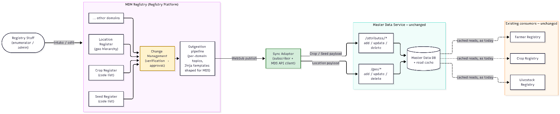
Figure 1: MDM Registry authoring and approval, synced to the Master Data Service; existing consumers read from MDS unchanged.
Why a dedicated MDM Registry deployment, rather than an extension bolted onto an existing registry: master data spans every domain registry (Farmer, CropSown, LiveStock, and whatever follows) rather than belonging to any single one of them. A dedicated deployment keeps its governance, RBAC, and blast radius independent of any one domain registry's own lifecycle
6. Component Responsibilities
Component | Responsibility
MDM Registry | Hosts each master-data domain as a Register. Runs the standard intake-form → change-log → verification → approval flow. Owns history and audit for every master-data change.
Change Management | The same g2p_register_change_log → verification → approval → history-then-live-write transaction every register already uses — unmodified.
Outgestion Pipeline | On CR approval, renders the change through a domain-specific outgoing template and publishes it to that domain's WebSub topic — unmodified.
Sync Adapter | Subscribes to each MDM domain's outgestion topic, calls the matching MDS write endpoint with a scoped service credential, and records delivery status per CR.
Master Data Service | Validates and persists the write through its existing CRUD API, serving reads to every downstream consumer exactly as today — unmodified.
7. Process Flow
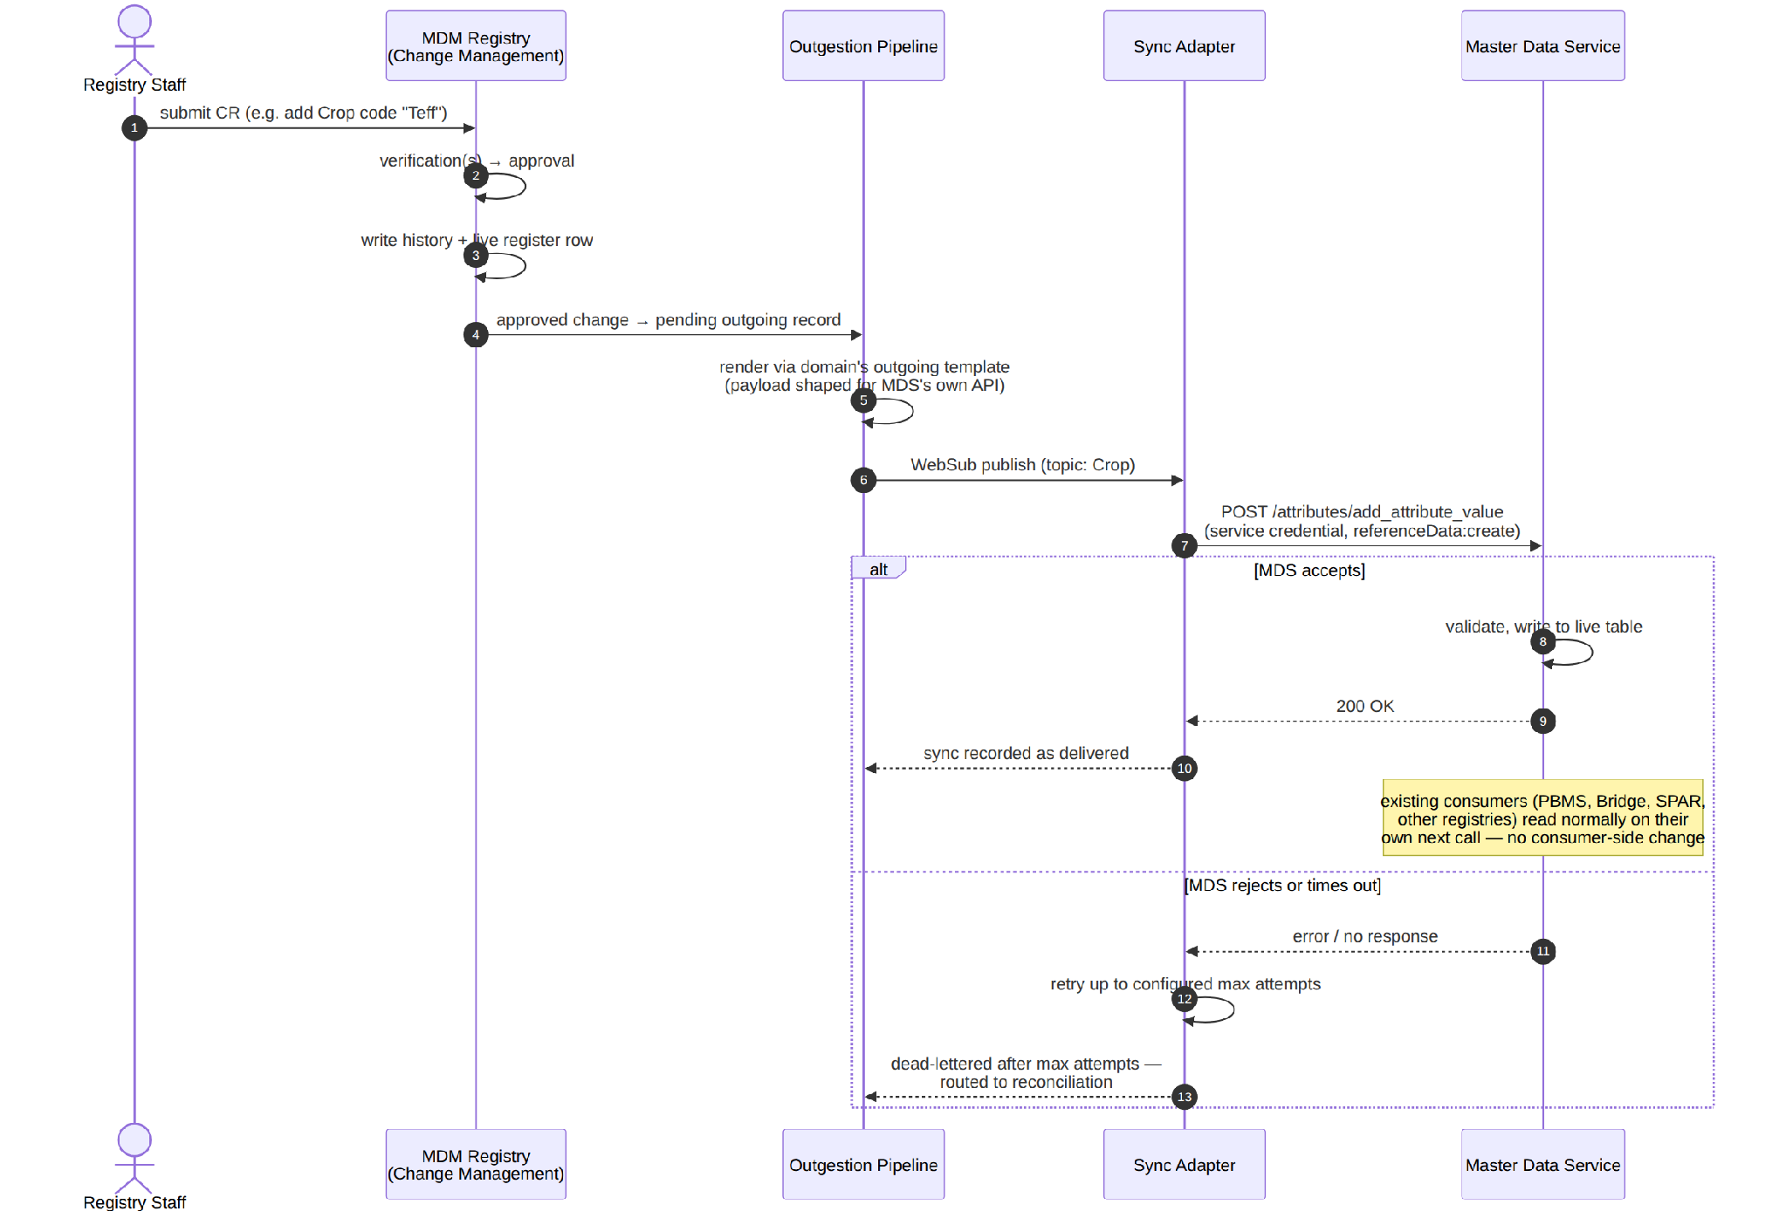
Figure 2: A change request from approval through the outgestion pipeline and Sync Adapter to the MDS write, with retry and dead-letter handling.
8. Domain Modeling
MDS has exactly two write domains. Every MDM Registry domain resolves to one of them at sync time:
MDM Registry domain | MDS domain | Endpoint family
Location | Geo (G2PGeoLevel / G2PGeoLevelValue) | /geo/add_geo_level, /geo/add_geo_level_value, /geo/update_*, /geo/delete_*
Crop | Attributes (G2PAttribute list CROP_TYPE / G2PAttributeValue) | /attributes/add_attribute_value, /attributes/update_attribute_value, /attributes/delete_attribute_value
Seed | Attributes, own list (SEED_VARIETY) | Same endpoint family as Crop
Any future flat code-list domain | Attributes, own list | Same endpoint family as Crop
Any future hierarchical domain | Geo | Same endpoint family as Location
Governance weight per domain:
- Location runs as a full Register with intake form and multi-step approval — hierarchy edits (splitting a kebele, adding a new woreda) get the full verification treatment.
- Crop and Seed start as lighter-weight catalogs: single-step approval within their Register, rather than multi-tier verification — proportionate to their lower change frequency and lower structural risk (a flat code addition, not a hierarchy edit). A domain moves to full multi-step approval if its change volume or risk profile grows to warrant it.
- Every future domain picks its governance weight the same way: full multi-step approval for anything structurally hierarchical or high-risk, single-step approval for flat, low-risk code lists.
9. API Integration
Field mapping — MDM Registry CR → MDS payload:
MDM Registry CR field | MDS endpoint | MDS payload field
Crop/Seed register: code, display_name | POST /attributes/add_attribute_value | attribute_code (the list, e.g. CROP_TYPE), value_code, display_name
Location register: level_mnemonic, parent_level_id | POST /geo/add_geo_level | level_mnemonic, parent_level_id
Location register: level_value_mnemonic, parent_level_value_id, level_id | POST /geo/add_geo_level_value | level_value_mnemonic, parent_level_value_id, level_id
Deactivation | POST /attributes/update_attribute_value or /geo/update_geo_level_value | Active/inactive flag on the existing value
Hard delete (used only where deactivation isn't available) | POST /attributes/delete_attribute_value or /geo/delete_geo_level_value | Per MDS's existing delete contract
Deletion policy: the Sync Adapter always prefers deactivation (an update that flips an active/inactive flag) over a hard delete. Hard delete is reserved for the cases where MDS has no deactivation path for that value type — a destructive operation is a deliberate, narrower choice than the default.
Authentication: the Sync Adapter authenticates to MDS as a scoped service identity — referenceData:create/edit/delete for Attribute-domain syncs, geo:create/edit/delete for Geo-domain syncs. Each domain's Sync Adapter credential carries only the permission its own writes need; a Crop-syncing credential never holds geo:* permissions, and vice versa.
Delivery guarantees: MDS write endpoints are treated as not idempotent. The Sync Adapter records delivery status per CR before sending, and checks that record before any retry, rather than assuming a resend is safe. Failed deliveries retry up to a configured maximum, then route to a dead-letter queue for reconciliation rather than retrying indefinitely.
Read consistency: MDS caches its read endpoints. The Sync Adapter does not assume a write immediately invalidates that cache — consumer-visible freshness is eventually consistent, bounded by the cache's configured TTL. The reconciliation job is the backstop that catches any write that lands but never becomes visible within that window.
Reconciliation: a scheduled job compares each domain's live state in the MDM Registry against its current state in MDS, flags drift, and re-drives any dead-lettered sync. This closes the gap a retried-and-failed delivery would otherwise leave open indefinitely — the same category of sweep a payments reconciliation job runs against asynchronous, at-least-once delivery.
Bootstrap / initial load: MDS's existing, already-seeded reference data (country-pack geo and attribute values that predate this design) is imported into the MDM Registry as an initial batch of pre-approved CRs — one CR per existing value, approved as part of the bootstrap rather than requiring a human to re-verify every pre-existing record. This gives every value a governance record from the point the MDM Registry goes live forward, without blocking rollout on manually re-approving the entire existing dataset.
10. Failure Modes
Failure | Sync Adapter behavior | Rationale
MDS temporarily unreachable | Retry up to worker_max_attempts, then dead-letter | Transient; mirrors the platform's existing outgestion resilience pattern
MDS rejects payload (validation error) | Dead-letter immediately, do not retry | Permanent until the CR itself is corrected — retrying a bad payload wastes attempts
MDS accepts but the read cache isn't busted | Not detectable by the Sync Adapter alone; caught by the reconciliation job | A “successful” write that isn't visible is a silent failure, not a loud one, so reconciliation — not the write call itself — is what closes it
Sync Adapter restarts mid-delivery | Checks prior delivery status before resending, per CR | Prevents duplicate creates against a non-idempotent endpoint
CR approved but its domain mapping doesn't cover a field | Template rendering fails and the record dead-letters, rather than sending an incomplete payload | A malformed sync silently corrupting MDS data is worse than a visibly stuck one
11. Security
- The Sync Adapter's MDS credential is scoped to exactly the permissions each domain's sync needs — least privilege, the same principle applied to every other service credential in this platform.
- Because MDS enforces no approval workflow of its own, the Sync Adapter's credential is the only thing standing between “an MDM Registry CR was approved” and “production reference data changed.” It is protected at least as carefully as any other production write credential in the system — a leak of it bypasses the governance model this design exists to provide.
- The Sync Adapter's own actions — what it sent to MDS, when, in response to which CR — are audited. This is the record that ties an MDS change back to the MDM Registry CR that authorized it, since MDS itself keeps none.
12. Rollout
- Build the first domain, Location, end to end: MDM Registry Register, outgoing template, Sync Adapter, one real CR carried through to a verified write in MDS.
- Run the bootstrap import of MDS's existing geo data into the MDM Registry as pre-approved CRs, and confirm the reconciliation job reports no drift between the two systems.
- Exercise the full failure-mode table above against Location in a non-production environment — including a forced MDS outage, a forced validation rejection, and a Sync Adapter restart mid-delivery — before this pattern is trusted with real production traffic.
- Onboard Crop and Seed using the same pattern, each starting with single-step approval per the governance-weight guidance above.
- Onboard further domains the same way as they arise, choosing Geo vs. Attributes and full vs. single-step approval per the rules already established for Location, Crop, and Seed.

